

TEHNICAL DATA SHEET
FISA DATE TEHNICE
Steel wall mount enclosure with sizes:
Cutii metalice de distributie cu dimensiunile in mm:

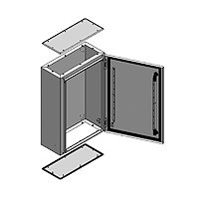
250X250x150
300X250X150
400X300X200
500X400X200
600X400X200
700X500X200
800X600X250
1000X800X300
1200X800X300
1400X800X300

Standard configuration:
- paint finish epoxy polyester powder coating textured finish color RAL 7032
- protection degree : ip66
- against mecanizal impacts: IK 10
- thickness: up to 700x500x200 1,2 mm, over that 1,5 mm
- mounting plate made of steel zinc coated thikness 2mm

Configuratie standard:
- vopsire in camp electrostatic cod de culoare RAL 7032
- grad de protectie IP 66
- protectie mecanica la impact IK 10
- grosime tabla 1.2mm pana la 700x500x200, dimensiunile mai mari 1.5mm
- contrapanou din table zincata montat in interior cu grosime 1.5mm pana la
700x500x200 iar peste aceasta dimensiune grosime 2mm

 29.01.2024
(date of issue)
(signature
Or Echivalent marking
Of authorized person)

